

Project Report

On

“EXAMINATION MANAGEMENT SYSTEM”

Submitted in the Partial fulfilment of the requirement for the Award of Degree of

Bachelor of Technology

in

COMPUTER SCIENCE & ENGINEERING

(2020-2024)

Submitted to: | Submitted by:
Er. Ajay Sharma (Associate Professor) | Danishpreet Singh (2000091)
 | Kirti Sharma (2000184)
Er. Anamika Jain (Assistant Professor) | Jitendra Kr (2000116)
 | Jitendra Kr Shah(2000189)

DEPARTMENT OF COMPUTER SCIENCE AND ENGINEERING

Amritsar Group of Colleges, Amritsar
ACKNOWLEDGEMENT

It is our proud privilege to release the feelings of our gratitude to several persons who helped us directly or indirectly to conduct this Analysis Project Work. We express our heart full thanks and owe a deep sense of gratitude to our teacher and my faculty guide Er. Ajay Sharma (Associate Professor, Department of CSE, Amritsar Group of Colleges, Amritsar) and Er. Neha Chadha

(Assistant Professor, Department of CSE, Amritsar Group of Colleges, Amritsar), for his guidance

and inspiration in completing this project.

We are extremely thankful to Dr. Sandeep Kad (Head of Department, Department of Computer Science & Engineering, Amritsar Group of Colleges) and all faculty members of CSE Department at Amritsar Group of Colleges, Amritsar for their co-ordination and co-operation and for their kind guidance and encouragement.

We also thank all our friends who have more or less contributed to the preparation of this project Report, we will be always indebted to them. This project completion has indeed helped us explore more knowledge avenues related to RDBMS/Python and we are sure it will help us in future too.

DECLARATION

We, hereby, declare that the project work entitled EXAMINATION MANAGEMENT SYSTEM submitted to Department of Computer Science & Engineering, AGC – Amritsar Group of Colleges, is a record of an original work done by us under the guidance of Er. Ajay Sharma, Er. Anamika Jain and this project work is submitted in the partial fulfilment of the requirements for the award of the degree of Bachelor of Technology in Computer Science & Engineering.

The results embodied in this report have not been submitted to any other University or Institute for the award of any degree or diploma.

Danishpreet Singh

Univ Roll No: 2000091

Kirti Sharma

Univ Roll No: 2000128

Jitendra Kr

Univ Roll No: 2000116

Jitendra Kr Shah

Univ Roll No: 2000117

TABLE OF CONTENTS

Sr. No. | Content | Page No.
1 | Introduction to RDBMS | 5
2 | Introduction to Python | 7
3 | Introduction of the Project | 8
4 | Objectives | 9
5 | Tools Used | 10
6 | Modules Used | 12
7 | Tables Used | 13
8 | Source Code | 15
9 | Screenshots | 48
10 | References | 55


INTRODUCTION TO RDBMS

Relational Data Model has an advantage that it is simple to implement and easy to understand as it uses table format. In this approach, a relation is only constructed by setting the association among the attributes of an entity as well the relationship among different entities. One of the main reasons for introducing this model was to increase the productivity of the application programmers by eliminating the need to change application program, when a change is made to the database. Data structure used in the data model is represented by both entities and relationship between them. Information is represented in the relational model in shape of tables. There are columns in a table which represent the attributes of an entity about which the table is constructed. The rows of a table are referred to as tuples.

1.1. STRUCTURED QUERY LANGUAGE

SQL tables, which consists of rows and columns, are used for storing data. The columns refer to the attributes. Each column in a table has a column name and a data type. A value’s data type associates a fixed set of properties with a value. The data types available in Oracle fall under the following categories.

Category Available data types

Character CHAR, VARCHAR, VARCHAR, NCHAR, NVARCHAR2, LONG, RAW,

LONGRAW

Number Number

Date/Time Date

LOB‟s BFILE, BLOB CLOB, NCLOB

WHAT IS A TABLE ?

A table is a database object which is used to store data in relational databases. Each table consists of rows and columns. A column in the database table represents the table’s attributes and a row represents a single set of column values in a database table. Each column of the table has a column name and a data type associated with it. The data types which can be used include VARCHAR2, NUMBER, DATE etc. A row of a table is also known as record. Within a table foreign keys are used to represent relationships.

CREATING A TABLE

In order to store and manage data it is necessary to create tables. In Oracle, tables are created using CREATE TABLE command which is one of the important DDL statement. The CREATE TABLE command specifies the name of the table, name of columns in the table as well as the data types and if required constraints associated with each column of the table.


INTEGRITY CONSTRAINTS IN CREATE TABLE

Oracle uses integrity constraints to prevent invalid data entry into the base tables of the database. One can define integrity constraints to enforce the business rules that one wants to associate with the information in the database. If the integrity constraints are violated due to the execution of any of DML statements (Insert, Update, Select) then Oracle rolls back the statement and returns an error. The different kinds of constraints are:
- Primary Key Constraint

- Unique Key Integrity Constraint

- NOT NULL Integrity Constraint

- Foreign Key Constraint

- Check Integrity Constraint

INTRODUCTION TO PYTHON

Python is a general purpose programming language that is often applied in scripting roles.

It is also called as Interpreted language.

The Origin of Python:

It is invented in Netherlands, in early 90’s and its implementation was started in December 1989. Guido Van Rossum is a fan of ‘Monty Python’s Flying Circus’, famous TV show in Netherlands. So he named the language after Monty Python.

Features Of Python:

- It’s Free: Downloading and installing Python is free and easy. Source code is easily accessible.

- Its Portable: Python runs virtually on every major platform used today. Programs runs exactly in the same manner irrespective of platform.

- It’s Powerful:: Dynamic typing , Built-in types and tools , library utilities , third-party utilities(e.g. Numpy , Scipy)

- It’s Mixable: Integration of python with other languages is widely used .

- It’s Relatively Easy to Use: Python Programs are compiled automatically to an intermediate

form called bytecode , which the interpreter then reads.

- It’s Relatively Easy to Learn

- Its Object – Oriented and Functional

Python is instead directly interpreted into machine instructions.

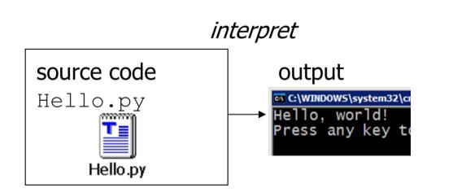

INTRODUCTION OF THE PROJECT

The "Cinema Booking System" has been developed to override the problems prevailing in the practicing manual system. This software is supported to eliminate and in some cases reduce the hardships faced by this existing system. Moreover this system is designed for the particular need of the company to carry out operations in a smooth and effective manner.
The application is reduced as much as possible to avoid errors while entering the data. It also provides error message while entering invalid data. No formal knowledge is needed for the user to use this system. Thus by this all it proves it is user-friendly. Cinema Booking System , as described above, can lead to error free, secure, reliable and fast management system. It can assist the user to concentrate on their other activities rather to concentrate on the record keeping. Thus it will help organization in better utilization of resources.
Every organization, whether big or small, has challenges to overcome and managing the information of Tickets, Movie, Show Timing, Audi, Customer. Every Cinema Booking System has different Movie needs. This is designed to assist in strategic planning, and will help you ensure that your organization is equipped with the right level of information and details for your future goals.

OBJECTIVES OF THE PROJECT

The main objective of the Project on Cinema Booking System is to manage the details of Movie, Tickets, Booking, Show Timing, Customer. It manages all the information about Movie, Audi, Customer, Movie. The project is totally built at administrative end and thus only the administrator is guaranteed the access. The purpose of the project is to build an application program to reduce the manual work for managing the Movie, Tickets, Audi, Booking. It tracks all the details about the Booking, Show Timing, Customer.
The purpose of Cinema Booking System is to automate the existing manual system by the help of computerized equipment and full-fledged computer software, fulfilling their requirements, so that their valuable data/information can be stored for a longer period with easy accessing and manipulation of the same. The required software and hardware are easily available and easy to work with.

Cinema Booking System, as described above, can lead to error free, secure, reliable and fast management system. It can assist the user to concentrate on their other activities rather to concentrate on the record keeping. Thus it will help organization in better utilization of resources. The organization can maintain computerized records without redundant entries. That means that one need not be distracted by information that is not relevant, while being able to reach the information.
The aim is to automate its existing manual system by the help of computerized equipment and full-fledged computer software, fulfilling their requirements, so that their valuable data/information can be stored for a longer period with easy accessing and manipulation of the same. Basically the project describes how to manage for good performance and better services for the clients.

TOOLS USED

Front-end: Python Tkinter

Back-end: Oracle Database

3.1 Introduction to Tkinter:-
Tkinter is the standard GUI library for python . Python when combined with Tkinter provides a fast and easy way to create GUI applications . Tkinter provides a powerful object oriented interface to the Tk GUI toolkit .

Creating a GUI application using Tkinter is an easy task . All you need to do is to perform the following steps –

- Import the Tkinter module.
- Create the GUI application main window .
- Add one or more widgets like label ,entry widgets or button to the GUI application.
- Enter the main event loop to take action against event triggered by the user.

3.2Introduction to Oracle Database

Oracle database (Oracle DB) is a relational database management system (RDBMS) from the Oracle Corporation. Originally developed in 1977 by Lawrence Ellison and other developers, Oracle DB is one of the most trusted and widely-used relational database engines.

The system is built around a relational database framework in which data objects may be directly accessed by users (or an application front end) through structured query language (SQL). Oracle is fully scalable relational database architecture and is often used by global enterprises, which manage and process data across wide and local area networks. The Oracle database has its own network component to allow communications across networks.

A key feature of Oracle is that its architecture is split between the logical and the physical. This structure means that for large-scale distributed computing, also known as grid computing, the data location is irrelevant and transparent to the user, allowing for a more modular physical structure that can be added to and altered without affecting the activity of the database, its data or users. The sharing of resources in this way allows for very flexible data networks whose capacity can be adjusted up or down to suit demand, without degradation of service. It also allows for a robust system to be devised as there is no single point at which a failure can bring down the database, as the networked schema of the storage resources means that any failure would be local only.


Modules of Cinema Booking System:
- Movie Management Module: Used for managing the Movie details.
- Customer Info Module : Used for managing the details of Customer
- Booking Module : Used for booking the tickets
- Movie earning Module: Used for managing the earnings of movie
- Login Module: Used for managing the login details
- Registration Module : Used for registering a customer.

Movie Management Module:- The manager can easily add movies info like Actor,Actress,Director, Movie Length, Type, Seats ,Theatre id.

Customer Info Module:- The Customer module simply contain information about the customers who has booked a ticket., and how many tickets of that

Movie Earning Module:- The Movie Earning module contain the information of movies earnings how many tickets are booked for each movie.

PASSWORD Module:- The Password module contain the information of all the registered users.

Registration Module:- The Registartion module contain the information of all the users who want to register.

TABLES USED IN THE PROJECT

• PASSWORD

COLUMN NAME | TYPE | CONSTRAINTS
USERNAME | VARCHAR2(20) | NOT NULL
PASSWORD | VARCHAR2(15)

• REGISTRATION

COLUMN NAME | TYPE | CONSTRAINTS
USERNAME | VARCHAR2(20) | NOT NULL
PASSWORD | VARCHAR2(10)
GENDER | VARCHAR2(7)
AGE | VARCHAR2(3)
MOBILE NO | VARCHAR2(10)

- MOVIE_DETAILS

Each semester of each course will have one table for the subjects

COLUMN NAME | TYPE | CONSTRAINTS
MOVIE_ID | VARCHAR2(20) | NOT NULL
MOVIE_NAME | VARCHAR2(10) | NOT NULL
MOVIE_TYPE | VARCHAR2(40)
RELEASE_DATE | VARCHAR2(10)
ACTOR | VARCHAR2(30)
ACTRESS | VARCHAR2(60)
DIRECTOR | VARCHAR2(20)
LENGTH | VARCHAR2(20)
SEATS | NUMBER(3)
THEATRE | VARCHAR2(20)

- MOVIEEARNINIG

COLUMN NAME | TYPE | CONSTRAINTS
MOVIE_ID | VARCHAR2(10) | NOT NULL
MOVIE_BOOKED | VARCHAR2(20) | NOT NULL
SEATS_BOOKED | NUMBER(4)
TOTAL_EARNING | NUMBER(7)

- CUSTOMER_INFO

Each semester of each course will have one table for the result of the students

COLUMN NAME | TYPE | CONSTRAINTS
CUST_ID | NUMBER(9) | NOT NULL
USERNAME | VARCHAR2(30)
SEATS | NUMBER(4)
MOVIE_BOOKED | VARCHAR2(40)

RESULT/MARK

SOURCECODE

# Creating a login page

from cProfile import label
from email import message
from email.mime import image
from re import U
from struct import pack
from sys import maxsize
from tkinter import *
from tkinter import messagebox
from turtle import bgcolor, dot, title, width
import tkinter.font as TkFont
import cx_Oracle
from PIL import Image,ImageTk

# Register Button function
def register():
from Register_form import Register
root2=Toplevel()
ob2=Register(root2)
user_name.delete(0,END)
user_password.delete(0,END)
root2.mainloop()

# It will Take you to the manager page
def manager():
from manager_choice import man_choice
root0=Toplevel()
ob1=man_choice(root0)
user_name.delete(0,END)
user_password.delete(0,END)
root0.mainloop()

# It will take you to the registration Page
def registaration():
from Register_form import Register
root1=Toplevel()
ob2=Register(root1)
user_name.delete(0,END)
user_password.delete(0,END)
root1.mainloop()
# Register(root0)

# It will take you to the customer page
def customer_page(u_name,u_id):
user_id=u_id
user_name=u_name
from customer import cust
root2=Toplevel()
ob3=cust(root2,user_name,user_id)
user_name.delete(0,END)
user_password.delete(0,END)
root2.mainloop()

# oracle connection
# def connect():
# con=cx_Oracle.connect('cinema/danish30')
# print(con.version)
# cursor=con.cursor()
# return cursor

# Cancel function
def cancel():
check=messagebox.askquestion("Permsission",'Do you Really Want to Exit')
if(check=='yes'):
root.destroy()

# Login function
def login():
u_name=user_name.get()
u_pass=user_password.get()
flag=-1

# checking if fields are empty or not
if u_name=="" and u_pass=="":
messagebox.showwarning('Login Error','Username And Password Required')

# checking if MANAGER has acess the system
elif u_name=='manager' and u_pass=="man123":

print('manager has acessed the system')
manager()

# Creting or checking a customer
elif u_name!="" and u_pass!="":
# con=cx_Oracle.connect('cinema/danish30')
# print(con.version)
# cursor=con.cursor()
# cursor.execute('select * from password')
# l=cursor.fetchall()
# user_cursor=connect()
con=cx_Oracle.connect('cinema/danish30')
print(con.version)
user_cursor=con.cursor()
user_cursor.execute('select * from password')
l=user_cursor.fetchall()
user_id=0
# user_id=l[2]
# print(user_id)
for i in l:
#checking the USERNAME in the database
if(u_name==i[0]) and(u_pass==i[1]):
user_id=i[2]
print(user_id)
flag=1
break
if(flag==1):
customer_page(u_name,user_id)

# if username is not in the database then go to registration page
else:
user_check=messagebox.showerror('User Error','USER NOT FOUND')
a=messagebox.askquestion('REGISTER','WANT TO REGISTER')
if(a=='yes'):
# Going to Registration page
registaration()

root=Tk()
root.geometry('1600x1204+0+0')
root.title("LOGIN PAGE")
# root.minsize(1255,944)
# root.maxsize(1255,944)
# root.resizable(0,0)
# "magneto",30,"bold"

font=TkFont.Font(family="Bold",weight="bold")
# title_font=TkFont.Font(family="Comic Sans MS",weight="bold")
title_font=("Arial Greek",30,"bold","italic")

login_image=ImageTk.PhotoImage(Image.open('1.jpg'))
login_label=Label(root,image=login_image).place(x=0,y=0,relwidth=1,relheight=1)

# CANVAS PORTION
# login_canvas=Canvas(root,width=200,height=200)
# login_icon=PhotoImage(file="b.png")
# login_canvas.create_image((130,150),image=login_icon)
# login_canvas.pack()

login_frame=Frame(root,bd=10,borderwidth=7,relief=RAISED)
login_frame.place(x=510,y=340,width=520)
login_frame_img=ImageTk.PhotoImage(Image.open('Blur.jpg'))
login_frame_label=Label(login_frame,image=login_frame_img)
login_frame_label.place(anchor='center')

# Title frame
title_frame=Frame(root)
title_frame.pack()
title_text=Label(title_frame,text='Welcome To AGC Cinema',font=("magneto",30,"bold"),bd=5,borderwidth=13,bg='#7d1515',relief=RAISED)
title_text.pack()

# Username and Passwords inputs
username=Label(login_frame,text='USERNAME :-',relief=RAISED,font=("rockwell",14,"bold"),bg='#6f747d',bd=4,width=14)
password=Label(login_frame,text='PASSWORD :-',relief=RAISED,font=("rockwell",14,"bold"),bg='#6f747d',bd=4,width=14)

user_name=Entry(login_frame,border=5,width=40,borderwidth=4,bg='#7d1515',relief=RIDGE,fg='white',font=("times new roman",9,"bold"))
user_password=Entry(login_frame,border=5,width=40,show='*',bg='#7d1515',relief=RIDGE,fg='white',font=("times new roman",9,"bold"))

username.grid(row=0,column=0,padx=21,pady=10)
password.grid(row=1,column=0)
user_name.grid(row=0,column=1,padx=20)
user_password.grid(row=1,column=1,padx=10)

# creating LOGIN button
login_button=Button(login_frame,text='Login',border=5,borderwidth=5,width=10,bg='#5e6269',font=("rockwell",14,"bold"),command= login,)
login_button.grid(row=2,column=1,pady=10)

# Creating Cancel Button
cancel_button=Button(login_frame,text='Cancel',border=5,borderwidth=5,width=10,bg='#ad1a1a',font=("rockwell",14,"bold"),command=cancel)
cancel_button.grid(row=3,column=1)

# register label
register_label=Button(login_frame,text="Register Now",font=("rockwell",14,"bold"),bg='#ad1a1a',border=5,borderwidth=5,command=registaration)
register_label.grid(row=3,column=0)

root.mainloop()

from cProfile import label
from email import message
from email.mime import image
from errno import ESTALE
from shutil import register_unpack_format
from sqlite3 import DatabaseError, Row
from struct import pack
from sys import maxsize
from tkinter import *
from tkinter import ttk
from tkinter import messagebox
from turtle import bgcolor, dot, title, width
import tkinter.font as TkFont
from random import *
import cx_Oracle
from PIL import Image,ImageTk
import tkinter as tk

class Register:
def __init__(self,winregister):
self.winregister=winregister
self.winregister.title('Registartion page')
self.winregister.geometry('1600x1204+0+0')
# self.winregister.minsize(1255,944)
# self.winregister.maxsize(1255,944)
self.label_font=TkFont.Font(family="Bold",weight="bold")

# Variables to be used to store users info
self.username=StringVar()
self.password=StringVar()
self.gender=StringVar()
self.age=StringVar()
self.number=StringVar()

self.login_image=ImageTk.PhotoImage(Image.open('1.jpg'))
login_label=Label(self.winregister,image=self.login_image)
login_label.place(x=0,y=0,relwidth=1,relheight=1)

# Creating a Registration Frame
register_frame=Frame(self.winregister)
register_frame.place(x=500,y=290,width=550,height=385)
self.register_frame_image=ImageTk.PhotoImage(Image.open('Blur.jpg'))
register_frame_label=Label(register_frame,image=self.register_frame_image)
register_frame_label.place(x=0,y=0,relwidth=1,relheight=1)

# Registration Title
title_frame=Frame(self.winregister)
title_frame.pack()
registration_text=Label(title_frame,text='Registration/...../Page',font=("magneto",30,"bold"),bd=5,borderwidth=13,bg='#7d1515',relief=RAISED)
registration_text.pack()

# Creating fields fro inputs
register_frame.columnconfigure(0,weight=3)
register_frame.columnconfigure(1,weight=3)

user_name=Label(register_frame,text='USERNAME :-',font=("rockwell",14,"bold"),bd=5,relief=RAISED,bg='#6f747d',width=12)
user_name.grid(row=0,column=0,padx=0,pady=17)

user_name_entry=Entry(register_frame,textvariable=self.username,width=30,relief=RIDGE,bg='#7d1515',bd=5,fg='white',cursor='arrow',font=("times",10,"bold"))
user_name_entry.grid(row=0,column=1,padx=5,pady=5)

user_password=Label(register_frame,text='PASSWORD :-',font=("rockwell",14,"bold"),bd=5,relief=RAISED,bg='#6f747d',width=12)
user_password.grid(row=1,column=0,padx=0,pady=13)

user_password_entry=Entry(register_frame,textvariable=self.password,width=30,relief=RIDGE,bg='#7d1515',bd=5,fg='white',font=("times",10,"bold"))
user_password_entry.grid(row=1,column=1,padx=5,pady=5)

user_gender=Label(register_frame,text='GENDER :-',font=("rockwell",14,"bold"),bd=5,relief=RAISED,bg='#6f747d',width=12)
user_gender.grid(row=2,column=0,pady=13)

user_gender_entry=ttk.Combobox(register_frame,textvariable=self.gender,width=22,font=("times new roman",13,"bold"))
user_gender_entry['values']=('male','female','other' )
# user_gender_entry.insert(0,'male or female')
user_gender_entry.grid(row=2,column=1,padx=5,pady=5)

user_age=Label(register_frame,text='AGE :-',font=("rockwell",14,"bold"),bd=5,relief=RAISED,bg='#6f747d',width=12)
user_age.grid(row=3,column=0,pady=13)

user_age_entry=Entry(register_frame,textvariable=self.age,width=30,relief=RIDGE,bg='#7d1515',bd=5,fg='white',font=("times",10,"bold"))
user_age_entry.grid(row=3,column=1,padx=5,pady=5)

user_number=Label(register_frame,text='MOBILE_NO :-',font=("rockwell",14,"bold"),bd=5,relief=RAISED,bg='#6f747d',width=12)
user_number.grid(row=4,column=0,pady=13)

user_number_entry=Entry(register_frame,textvariable=self.number,width=30,relief=RIDGE,bg='#7d1515',bd=5,fg='white',font=("times",10,"bold"))
user_number_entry.grid(row=4,column=1,padx=5,pady=5)

submit_button=Button(register_frame,text='SUBMIT',bd=6,borderwidth=9,bg='#5e6269',command=self.submit_data,width=15,font=("rockwell",14,"bold"))
submit_button.grid(row=5,column=1,padx=5,pady=5)

self.winregister=mainloop()

def submit_data(self):
if self.username.get()=="" or self.password.get()=="" or self.gender.get()=="" or self.age.get()=="" or self.number.get()=="":
messagebox.showerror("Error","All (*) Fields Are Required!!!",parent=self.winregister)

else:
user_id=0
user_id=randint(1000,2000)
u=self.username.get()
p=self.password.get()
g=self.gender.get()
a=self.age.get()
m=self.number.get()

# Connecting to the DATABASE
con=cx_Oracle.connect('cinema/danish30')
print(con.version)
cursor=con.cursor()
try:

cursor.execute("INSERT INTO REGISTRATION VALUES(:1,:2,:3,:4,:5)",(u,p,g,a,m))
cursor.execute("INSERT INTO PASSWORD VALUES(:1,:2,:3)",(u,p,user_id))
cursor.execute("INSERT INTO CUSTOMER (custid,username) VALUES (:u_id,:u_name)",u_id=user_id,u_name=u)

except cx_Oracle.IntegrityError:
messagebox.showerror("ALREADY EXISTED","CUSTOMER ALREADY EXISTED")

else:
con.commit()
con.close()
a=messagebox.showinfo("COMPLETED","REGISTRATION SUCCESFUL")
if (a=='ok'):
self.winregister.destroy()
# b=messagebox.askyesno("PERMISSION","GO BACK TO THE LOGIN PAGE")
# if(b=='yes'):
# self.winregister.quit()

# root0=Toplevel()
# ob=Register(root0)
# root0.mainloop()

if __name__ =="main":
winregister=Tk()
ob=Register(winregister)
winregister.mainloop()

from cProfile import label
from email import message
from email.mime import image
from re import U
from struct import pack
from sys import maxsize
from tkinter import *
from tkinter import messagebox
from turtle import bgcolor, dot, title, width
import tkinter.font as TkFont
import cx_Oracle
from PIL import Image,ImageTk

class man_choice:
def __init__(self,winmanager):
self.winmanager=winmanager
self.winmanager.title('MANAGER CHOICE PAGE')
self.winmanager.geometry('1600x1204+0+0')

self.login_image=ImageTk.PhotoImage(Image.open('1.jpg'))
login_label=Label(self.winmanager,image=self.login_image)
login_label.place(x=0,y=0,relwidth=1,relheight=1)

title_frame=Frame(self.winmanager)
title_frame.pack()
registration_text=Label(title_frame,text='What Would You Like To Do',font=("magneto",30,"bold"),bd=5,borderwidth=13,bg='#7d1515',relief=RAISED)
registration_text.pack()

login_frame=Frame(self.winmanager,bd=10,borderwidth=7,relief=RAISED)
login_frame.place(x=510,y=340,width=520,height=180)
self.login_frame_img=ImageTk.PhotoImage(Image.open('Blur.jpg'))
login_frame_label=Label(login_frame,image=self.login_frame_img)
login_frame_label.place(anchor='center')

movies_page=Button(login_frame,text='MANAGE MOVIES',border=5,borderwidth=5,width=15,bg='#ad1a1a',font=("rockwell",15,"bold"),command=self.movies)
movies_page.grid(row=0,column=0,pady=15,padx=10)

movies_earning_page=Button(login_frame,text='MOVIES EARNING',border=5,borderwidth=5,width=15,bg='#ad1a1a',font=("rockwell",15,"bold"),command=self.earning)
movies_earning_page.grid(row=0,column=1,pady=10,padx=15)

customer_info_page=Button(login_frame,text='CUSTOMER INFO',border=5,borderwidth=5,width=15,bg='#ad1a1a',font=("rockwell",15,"bold"),command=self.custinfo)
customer_info_page.grid(row=1,column=0,pady=25,padx=22)

quit=Button(login_frame,text='QUIT',border=5,borderwidth=5,width=15,bg='#ad1a1a',font=("rockwell",15,"bold"),command=self.quit)
quit.grid(row=1,column=1,pady=22,padx=23)

def movies(self):
from manager_page import manage
root0=Toplevel()
ob1=manage(root0)
root0.mainloop()

def custinfo(self):
from customer_info import cust_info
root0=Toplevel()
ob1=cust_info(root0)
root0.mainloop()

def earning(self):
from movie_earning import m_earning
root0=Toplevel()
ob1=m_earning(root0)
root0.mainloop()

def quit(self):
self.winmanager.destroy()

root0=Toplevel()
ob=man_choice(root0)
root0.mainloop()

if __name__ =="main":
winearning=Tk()
ob=man_choice(winearning)
winearning.mainloop()

from cProfile import label
from email import message
from email.mime import image
from platform import release
from struct import pack
from sys import maxsize
from tkinter import *
from tkinter import messagebox
from turtle import bgcolor, dot, title, up, width
import tkinter.font as TkFont
from tkinter import ttk
from webbrowser import BackgroundBrowser
import cx_Oracle
from PIL import Image,ImageTk

class manage():
def __init__(self,winmanager):
self.winmanager=winmanager
self.winmanager.title('Manager page')
self.winmanager.geometry('1600x1204+0+0')
# self.winmanager.minsize(1255,944)
# self.winmanager.maxsize(1255,944)
l1=Label(self.winmanager,text="welvome")
l1.pack()

# Variables to use
self.movieid_var=StringVar()
self.moviename_var=StringVar()
self.movietype_var=StringVar()
self.movierdate=StringVar()
self.movieactor_var=StringVar()
self.movieactress_var=StringVar()
self.moviedirector_var=StringVar()
self.movielength_var=StringVar()
self.movieseats_var=StringVar()
self.movietheatre_var=StringVar()

self.login_image=ImageTk.PhotoImage(Image.open('2.jpg'))
login_label=Label(self.winmanager,image=self.login_image)
login_label.place(x=0,y=0,relwidth=1,relheight=1)

title_frame=Frame(self.winmanager)
title_frame.pack()
registration_text=Label(title_frame,text='Movie/..../Managing',font=("magneto",30,"bold"),bd=5,borderwidth=13,bg='#7d1515',relief=RAISED)
# registration_text.place(x=20,y=0,relx=1,rely=1)
registration_text.pack()

#LeftSideFrame//////////////////////////////////////////////////////////////////
f1=Frame(self.winmanager,bd=4,relief=RAISED,borderwidth=7,bg='#5e6269')
f1.place(x=30,y=135,width=420,height=640)

f1.columnconfigure(0,weight=3)
f1.columnconfigure(1,weight=3)

movie_id=Label(f1,text='MOVIE ID :-',font=("rockwell",12,"bold"),bd=5,relief=RAISED,bg='#6f747d',width=15)
movie_id.grid(row=0,column=0,padx=0,pady=14)

movie_id_entry=Entry(f1,textvariable=self.movieid_var,width=30,relief=SUNKEN,bg='#7d1515',bd=5,fg='white',font=("rockwell",10,"bold"))
movie_id_entry.grid(row=0,column=1,padx=5,pady=5)

movie_name=Label(f1,text='NAME :-',font=("rockwell",12,"bold"),bd=5,relief=RAISED,bg='#6f747d',width=15)
movie_name.grid(row=1,column=0,padx=0,pady=8)

movie_name_entry=Entry(f1,textvariable=self.moviename_var,width=30,relief=SUNKEN,bg='#7d1515',bd=5,fg='white',font=("rockwell",10,"bold"))
movie_name_entry.grid(row=1,column=1,padx=5,pady=5)

movie_type=Label(f1,text='TYPE :-',font=("rockwell",12,"bold"),bd=5,relief=RAISED,bg='#6f747d',width=15)
movie_type.grid(row=2,column=0,pady=8)

movie_type_entry=Entry(f1,textvariable=self.movietype_var,width=30,relief=SUNKEN,bg='#7d1515',bd=5,fg='white',font=("rockwell",10,"bold"))
# movie_type_entry.insert(0,'male or female')
movie_type_entry.grid(row=2,column=1,padx=5,pady=5)

release_date=Label(f1,text='RELEASE DATE :-',font=("rockwell",12,"bold"),bd=5,relief=RAISED,bg='#6f747d',width=15)
release_date.grid(row=3,column=0,pady=8)

release_date_entry=Entry(f1,textvariable=self.movierdate,width=30,relief=SUNKEN,bg='#7d1515',bd=5,fg='white',font=("rockwell",10,"bold"))
release_date_entry.grid(row=3,column=1,padx=5,pady=5)

movie_actor=Label(f1,text='ACTOR :-',font=("rockwell",12,"bold"),bd=5,relief=RAISED,bg='#6f747d',width=15)
movie_actor.grid(row=4,column=0,pady=8)

movie_actor_entry=Entry(f1,textvariable= self.movieactor_var,width=30,relief=SUNKEN,bg='#7d1515',bd=5,fg='white',font=("rockwell",10,"bold"))
movie_actor_entry.grid(row=4,column=1,padx=5,pady=5)

movie_actoress=Label(f1,text='ACTRESS :-',font=("rockwell",12,"bold"),bd=5,relief=RAISED,bg='#6f747d',width=15)
movie_actoress.grid(row=5,column=0,pady=8)

movie_actoress_entry=Entry(f1,textvariable= self.movieactress_var,width=30,relief=SUNKEN,bg='#7d1515',bd=5,fg='white',font=("rockwell",10,"bold"))
movie_actoress_entry.grid(row=5,column=1,padx=5,pady=5)

movie_director=Label(f1,text='DIRECTOR :-',font=("rockwell",12,"bold"),bd=5,relief=RAISED,bg='#6f747d',width=15)
movie_director.grid(row=6,column=0,pady=8)

movie_director_entry=Entry(f1,textvariable=self.moviedirector_var,width=30,relief=SUNKEN,bg='#7d1515',bd=5,fg='white',font=("rockwell",10,"bold"))
movie_director_entry.grid(row=6,column=1,padx=5,pady=5)

movie_length=Label(f1,text='LENGTH :-',font=("rockwell",12,"bold"),bd=5,relief=RAISED,bg='#6f747d',width=15)
movie_length.grid(row=7,column=0,pady=8)

movie_length_entry=Entry(f1,textvariable=self.movielength_var,width=30,relief=SUNKEN,bg='#7d1515',bd=5,fg='white',font=("rockwell",10,"bold"))
movie_length_entry.grid(row=7,column=1,padx=5,pady=5)

movie_seats=Label(f1,text='SEATS :-',font=("rockwell",12,"bold"),bd=5,relief=RAISED,bg='#6f747d',width=15)
movie_seats.grid(row=8,column=0,pady=8)

movie_seats_entry=Entry(f1,textvariable=self.movieseats_var,width=30,relief=SUNKEN,bg='#7d1515',bd=5,fg='white',font=("rockwell",10,"bold"))
movie_seats_entry.grid(row=8,column=1,padx=5,pady=5)

movie_theatre=Label(f1,text='THEATRE :-',font=("rockwell",12,"bold"),bd=5,relief=RAISED,bg='#6f747d',width=15)
movie_theatre.grid(row=9,column=0,pady=8)

movie_theatre_entry=Entry(f1,textvariable=self.movietheatre_var,width=30,relief=SUNKEN,bg='#7d1515',bd=5,fg='white',font=("rockwell",10,"bold"))
movie_theatre_entry.grid(row=9,column=1,padx=5,pady=5)

insert_button=Button(f1,text='INSERT',bd=6,borderwidth=6,bg='#ad1a1a',width=15,font=("rockwell",12,"bold"),command=self.add_data)
insert_button.grid(row=10,column=0,padx=5,pady=10)

update_button=Button(f1,text='UPDATE',bd=6,borderwidth=6,bg='#ad1a1a',width=15,font=("rockwell",12,"bold"),command=self.update_data)
update_button.grid(row=10,column=1,padx=5,pady=20)

delete_button=Button(f1,text='DELETE',bd=6,borderwidth=6,bg='#ad1a1a',width=15,font=("rockwell",12,"bold"),command=self.delete_data)
delete_button.grid(row=11,column=0,padx=5,pady=5)

clear_button=Button(f1,text='CLEAR',bd=6,borderwidth=6,bg='#ad1a1a',width=15,font=("rockwell",12,"bold"),command=self.clear_data)
clear_button.grid(row=11,column=1,padx=5,pady=5)

quit_buttom=Button(self.winmanager,text="QUIT AND GO BACK",bd=7,borderwidth=9,bg='#ad1a1a',width=22,font=("rockwell",14,"bold"),command=self.quit)
quit_buttom.place(x=880,y=720)

#TreeviewFrame///////////////////////////////////////////////////////////////////
f2=Frame(self.winmanager,bd=4,borderwidth=12,relief=RIDGE,bg='#5e6269')
f2.place(x=590,y=136,width=900,height=560)
scroll_x=Scrollbar(f2,orient=HORIZONTAL)
scroll_y=Scrollbar(f2,orient=VERTICAL)

self.Movie_Table=ttk.Treeview(f2,columns=("ID","NAME","TYPE","RELEASE DATE","HEROES","HEROINES","DIRECTOR","LENGTH","SEATS","THEATRE"),xscrollcommand=scroll_x.set,yscrollcommand=scroll_y.set)

scroll_x.pack(side=BOTTOM,fill=X)
scroll_y.pack(side=RIGHT,fill=Y)
scroll_x.config(command=self.Movie_Table.xview)
scroll_y.config(command=self.Movie_Table.yview)

style = ttk.Style()
style.theme_use("clam")
style.configure("Treeview.Heading", font=("rockwell",15,"bold"),fieldbackground='#ad1a1a',background='#ad1a1a')
style.configure("Treeview",background='#5e6269',fieldbackground='#5e6269',fieldforground="white",forground="white",font=("rockwell",13))
# style.theme_use("vista")

self.Movie_Table.heading("ID",text="ID")
self.Movie_Table.heading("NAME",text="NAME")
self.Movie_Table.heading("TYPE",text="TYPE")
self.Movie_Table.heading("RELEASE DATE",text="RELEASE DATE")
self.Movie_Table.heading("HEROES",text="HEROES")
self.Movie_Table.heading("HEROINES",text="HEROINES")
self.Movie_Table.heading("DIRECTOR",text="DIRECTOR")
self.Movie_Table.heading("LENGTH",text="LENGTH")
self.Movie_Table.heading("SEATS",text="SEATS")
self.Movie_Table.heading("THEATRE",text="THEATRE")
self.Movie_Table['show']="headings"
self.Movie_Table.column("ID",width=100)
self.Movie_Table.column("NAME",width=270)
self.Movie_Table.column("TYPE",width=300)
self.Movie_Table.column("RELEASE DATE",width=120)
self.Movie_Table.column("HEROES",width=270)
self.Movie_Table.column("HEROINES",width=250)
self.Movie_Table.column("DIRECTOR",width=150)
self.Movie_Table.column("LENGTH",width=80)
self.Movie_Table.column("SEATS",width=80)
self.Movie_Table.column("THEATRE",width=120)
self.Movie_Table.bind("<ButtonRelease-1>",self.get_data)

self.Movie_Table.pack(fill=BOTH,expand=1)
self.fetch_data()

# Class Methods///////////////////////////////////////////////////////////////////////////////

def add_data(self):
if self.movieid_var.get()=="" or self.moviename_var.get()==""or self.movietype_var.get()==""or self.movierdate.get()==""or self.movieactor_var.get()=="" or self.movieactress_var.get()=="" or self.moviedirector_var.get()=="" or self.movielength_var.get()=="" or self.movieseats_var.get()=="" or self.movietheatre_var.get()=="":
messagebox.showerror("Error","All (*) Fields Are Required!!!",parent=self.winmanager)
else:
I=self.movieid_var.get()
N=self.moviename_var.get()
TY=self.movietype_var.get()
DA=self.movierdate.get()
AT=self.movieactor_var.get()
AR=self.movieactress_var.get()
DI=self.moviedirector_var.get()
L=self.movielength_var.get()
S=eval(self.movieseats_var.get())
TH=self.movietheatre_var.get()
price=0
# Connecting to the DATABASE
con=cx_Oracle.connect('cinema/danish30')
print(con.version)
cursor=con.cursor()
try:
cursor.execute("INSERT INTO movie_details VALUES(:1,:2,:3,:4,:5,:6,:7,:8,:9,:10)",(I,N,TY,DA,AT,AR,DI,L,S,TH))
cursor.execute("INSERT INTO movie_earning(MOVIE_ID,MOVIE_NAME,total_earning) VALUES(:id,:nm,:er)",id=I,nm=N,er=price)
except cx_Oracle.IntegrityError:
messagebox.showerror("ALREADY EXISTED","MOVIE ALREADY EXISTED")

else:
con.commit()
self.fetch_data()
con.close()
a=messagebox.showinfo("COMPLETED","MOVIE ADDED SUCCESFULLY")
# if (a=='ok'):
# b=messagebox.askyesno("PERMISSION","GO BACK TO THE LOGIN PAGE")
# if(b=='yes'):
# self.winmanager.quit()

def get_data(self,event):
cursor_row=self.Movie_Table.focus()
contents=self.Movie_Table.item(cursor_row)
row=contents['values']
self.movieid_var.set(row[0])
self.moviename_var.set(row[1])
self.movietype_var.set(row[2])
self.movierdate.set(row[3])
self.movieactor_var.set(row[4])
self.movieactress_var.set(row[5])
self.moviedirector_var.set(row[6])
self.movielength_var.set(row[7])
self.movieseats_var.set(row[8])
self.movietheatre_var.set(row[9])

def fetch_data(self):
con=cx_Oracle.connect("cinema/danish30")
cur=con.cursor()
cur.execute("select * from Movie_Details")
rows = cur.fetchall()
if (rows)!=0:
self.Movie_Table.delete(*self.Movie_Table.get_children())
for row in rows:
self.Movie_Table.insert('',END,values=row)
con.commit()
con.close()

def update_data(self):
if self.movieid_var.get()=="" or self.moviename_var.get()==""or self.movietype_var.get()==""or self.movierdate.get()==""or self.movieactor_var.get()=="" or self.movieactress_var.get()=="" or self.moviedirector_var.get()=="" or self.movielength_var.get()=="" or self.movieseats_var.get()=="" or self.movietheatre_var.get()=="":
messagebox.showerror("Error","All (*) Fields Are Required!!!",parent=self.winmanager)

else:
I=self.movieid_var.get()
N=self.moviename_var.get()
TY=self.movietype_var.get()
DA=self.movierdate.get()
AT=self.movieactor_var.get()
AR=self.movieactress_var.get()
DI=self.moviedirector_var.get()
L=self.movielength_var.get()
S=eval(self.movieseats_var.get())
TH=self.movietheatre_var.get()
# Connecting to the DATABASE
con=cx_Oracle.connect('cinema/danish30')
print(con.version)
cursor=con.cursor()
try:
cursor.execute("UPDATE MOVIE_DETAILS SET MOVIE_NAME= :1,MOVIE_TYPE= :2,RELEASE_DATE= :3,ACTOR= :4,ACTORESS= :5,DIRECTOR= :6,LENGTH= :7 ,SEATS= :8,THEATRE= :9 WHERE MOVIE_ID LIKE '%s'"%I,(N,TY,DA,AT,AR,DI,L,S,TH))
# cursor.execute("UPDATE MOVIE_EARNING SET MOVIE_NAME= :nm WHERE MOVIE_ID = :id",id=I)
# sql="UPDATE MOVIE_DETAILS SET MOVIE_NAME=:2,MOVIE_TYPE=:3,RELEASE_DATE=:4,ACTOR=:5,ACTORESS=:6,DIRECTOR=:7,LENGTH=:8 ,SEATS=:9,THEATRE=:10,where MOVIE_ID=:1"
# cursor.execute (sql,(N,TY,DA,AT,AR,DI,L,S,TH,I))
con.commit()
self.fetch_data()
con.close()
except cx_Oracle.IntegrityError:
messagebox.showerror("ALREADY EXISTED","MOVIE ALREADY EXISTED IN THE LIST")

else:

messagebox.showinfo("SUCCESS","RECORD UPDATED SUCCESFULLY",parent=self.winmanager)
# if (a=='ok'):
# b=messagebox.askyesno("PERMISSION","GO BACK TO THE LOGIN PAGE")
# if(b=='yes'):
# self.winmanager.quit()

def delete_data(self):
I=self.movieid_var.get()
if I=="":
messagebox.showerror("Error","Movie ID is Required to Delete the record!!",parent=self.winmanager)
else:
con=cx_Oracle.connect("cinema/danish30")
cur=con.cursor()
cur.execute("Delete From Movie_Details where MOVIE_ID = :id",id=I)
#rows = cur.fetchall()
con.commit()
self.fetch_data()
con.close()
messagebox.showinfo("Success","Record Deleted Successfully",parent=self.winmanager)

def clear_data(self):

# if self.movieid_var.get()=="" or self.moviename_var.get()==""or self.movietype_var.get()==""or self.movierdate.get()==""or self.movieactor_var.get()=="" or self.movieactress_var.get()=="" or self.moviedirector_var.get()=="" or self.movielength_var.get()=="" or self.movieseats_var.get()=="" or self.movietheatre_var.get()=="":

# messagebox.showerror("Error","All (*) Fields Are Required!!!",parent=self.winmanager)

self.movieid_var.set('')
self.moviename_var.set('')
self.movietype_var.set('')
self.movierdate.set('')
self.movieactor_var.set('')
self.movieactress_var.set('')
self.moviedirector_var.set('')
self.movielength_var.set('')
self.movieseats_var.set('')
self.movietheatre_var.set('')
# messagebox.showinfo("Success","Fields Cleared Successfully",parent =self.winmanager)

def quit(self):
self.winmanager.destroy()

root0=Toplevel()
ob=manage(root0)
root0.mainloop()

if __name__ =="main":
winmanager=Tk()
ob=manage(winmanager)
winmanager.mainloop()

from cProfile import label
from dataclasses import InitVar
from email import message
from email.mime import image
from operator import imatmul
from platform import release
from re import L
from struct import pack
from sys import maxsize
from tkinter import *
from tkinter import messagebox
from tokenize import String
from turtle import bgcolor, dot, title, up, width
import tkinter.font as TkFont
from tkinter import ttk
from typing import List
from webbrowser import BackgroundBrowser
import cx_Oracle
from PIL import Image,ImageTk

class cust_info:
def __init__(self,winearning):
self.winearning=winearning
self.winearning.title("Customer Info")
self.winearning.geometry('1600x1204+0+0')

self.login_image=ImageTk.PhotoImage(Image.open('4.jpg'))
login_label=Label(self.winearning,image=self.login_image)
login_label.place(x=0,y=0,relwidth=1,relheight=1)
# Title Frame//////////////////////////////////////////////////////////////////
title_frame=Frame(self.winearning)
title_frame.pack()
registration_text=Label(title_frame,text='Customer Info/...../Page',font=("magneto",30,"bold"),bd=5,borderwidth=13,bg='#7d1515',relief=RAISED)
registration_text.pack()

quit_buttom=Button(self.winearning,text="QUIT AND GO BACK",bd=7,borderwidth=9,bg='#ad1a1a',width=22,font=("rockwell",14,"bold"),command=self.quit)
quit_buttom.place(x=620,y=720)

f2=Frame(self.winearning,bd=4,borderwidth=12,relief=RAISED,bg='#5e6269')
f2.place(x=373,y=130,width=800,height=560)
scroll_x=Scrollbar(f2,orient=HORIZONTAL)
scroll_y=Scrollbar(f2,orient=VERTICAL)

self.Movie_Table=ttk.Treeview(f2,columns=("CUST_ID","USERNAME","SEATS","MOVIE_BOOKED"),yscrollcommand=scroll_y.set)

# scroll_x.pack(side=BOTTOM,fill=X)
scroll_y.pack(side=RIGHT,fill=Y)
# scroll_x.config(command=self.Movie_Table.xview)
scroll_y.config(command=self.Movie_Table.yview)

style = ttk.Style()
style.theme_use("clam")
style.configure("Treeview.Heading", font=("rockwell",13,"bold"),fieldbackground='#ad1a1a',background='#ad1a1a')
style.configure("Treeview",background='#5e6269',fieldbackground='#5e6269',fieldforground="white",forground="white",font=("rockwell",12,"bold"))

self.Movie_Table.heading("CUST_ID",text="CUST_ID")
self.Movie_Table.heading("USERNAME",text="USERNAME")
self.Movie_Table.heading("SEATS",text="SEATS")
self.Movie_Table.heading("MOVIE_BOOKED",text="MOVIE_BOOKED")
self.Movie_Table['show']="headings"
self.Movie_Table.column("CUST_ID",width=80)
self.Movie_Table.column("USERNAME",width=200)
self.Movie_Table.column("SEATS",width=120)
self.Movie_Table.column("MOVIE_BOOKED",width=100)
self.Movie_Table.pack(fill=BOTH,expand=1)
self.fetch_data()

def fetch_data(self):
con=cx_Oracle.connect("cinema/danish30")
cur=con.cursor()
cur.execute(" SELECT CUSTID,USERNAME,SEATS,MOVIE_BOOKED FROM CUSTOMER")
rows = cur.fetchall()
if (rows)!=0:
self.Movie_Table.delete(*self.Movie_Table.get_children())
for row in rows:
self.Movie_Table.insert('',END,values=row)
con.commit()
con.close()

def quit(self):
self.winearning.destroy()

root0=Toplevel()
ob=cust_info(root0)
root0.mainloop()

if __name__ =="main":
winearning=Tk()
ob=cust_info(winearning)
winearning.mainloop()

from cProfile import label
from dataclasses import InitVar
from email import message
from email.mime import image
from operator import imatmul
from platform import release
from re import L
from struct import pack
from sys import maxsize
from tkinter import *
from tkinter import messagebox
from tokenize import String
from turtle import bgcolor, dot, title, up, width
import tkinter.font as TkFont
from tkinter import ttk
from typing import List
from webbrowser import BackgroundBrowser
import cx_Oracle
from PIL import Image,ImageTk

class m_earning:
def __init__(self,winearning):
self.winearning=winearning
self.winearning.title("Movie earning")
self.winearning.geometry('1600x1204+0+0')

self.login_image=ImageTk.PhotoImage(Image.open('4.jpg'))
login_label=Label(self.winearning,image=self.login_image)
login_label.place(x=0,y=0,relwidth=1,relheight=1)
# Title Frame//////////////////////////////////////////////////////////////////
title_frame=Frame(self.winearning)
title_frame.pack()
registration_text=Label(title_frame,text='Movies Earning/...../Page',font=("magneto",30,"bold"),bd=5,borderwidth=13,bg='#7d1515',relief=RAISED)
registration_text.pack()

quit_buttom=Button(self.winearning,text="QUIT AND GO BACK",bd=7,borderwidth=9,bg='#ad1a1a',width=22,font=("magneto",14,"bold"),command=self.quit)
quit_buttom.place(x=620,y=720)

f2=Frame(self.winearning,bd=4,borderwidth=12,relief=RAISED,bg='#5e6269')
f2.place(x=373,y=130,width=800,height=560)
scroll_x=Scrollbar(f2,orient=HORIZONTAL)
scroll_y=Scrollbar(f2,orient=VERTICAL)

self.Movie_Table=ttk.Treeview(f2,columns=("MOVIE_ID","NAME","EARNINGS","SEATS_BOOKED"),yscrollcommand=scroll_y.set)

# scroll_x.pack(side=BOTTOM,fill=X)
scroll_y.pack(side=RIGHT,fill=Y)
# scroll_x.config(command=self.Movie_Table.xview)
scroll_y.config(command=self.Movie_Table.yview)

style = ttk.Style()
style.theme_use("clam")
style.configure("Treeview.Heading", font=("times new roman",13,"bold"),fieldbackground='#ad1a1a',background='#ad1a1a')
style.configure("Treeview",background='#5e6269',fieldbackground='#5e6269',fieldforground="white",forground="white",font=("times new roman",12,"bold"))

self.Movie_Table.heading("MOVIE_ID",text="MOVIE_ID")
self.Movie_Table.heading("NAME",text="NAME")
self.Movie_Table.heading("EARNINGS",text="EARNINGS")
self.Movie_Table.heading("SEATS_BOOKED",text="SEATS_BOOKED")
self.Movie_Table['show']="headings"
self.Movie_Table.column("MOVIE_ID",width=80)
self.Movie_Table.column("NAME",width=200)
self.Movie_Table.column("EARNINGS",width=120)
self.Movie_Table.column("SEATS_BOOKED",width=80)
self.Movie_Table.pack(fill=BOTH,expand=1)
self.fetch_data()

def fetch_data(self):
con=cx_Oracle.connect("cinema/danish30")
cur=con.cursor()
cur.execute(" select movie_id,movie_name,total_earning,seats_booked from movie_earning")
rows = cur.fetchall()
if (rows)!=0:
self.Movie_Table.delete(*self.Movie_Table.get_children())
for row in rows:
self.Movie_Table.insert('',END,values=row)
con.commit()
con.close()

def quit(self):
self.winearning.destroy()

# root0=Toplevel()
# ob=m_earning(root0)
# root0.mainloop()

if __name__ =="main":
winearning=Tk()
ob=m_earning(winearning)
winearning.mainloop()

from cProfile import label
from dataclasses import InitVar
from email import message
from email.mime import image
from operator import imatmul
from platform import release
from re import L
from struct import pack
from sys import maxsize
from tkinter import *
from tkinter import messagebox
from tokenize import String
from turtle import bgcolor, dot, title, up, width
import tkinter.font as TkFont
from tkinter import ttk
from typing import List
from webbrowser import BackgroundBrowser
import cx_Oracle
from PIL import Image,ImageTk

class cust:
def __init__(self,wincustomer,u_name,u_id):

self.wincustomer=wincustomer
self.wincustomer.geometry('1600x1204+0+0')
self.wincustomer.title("Customer Page")

self.login_image=ImageTk.PhotoImage(Image.open('4.jpg'))
login_label=Label(self.wincustomer,image=self.login_image)
login_label.place(x=0,y=0,relwidth=1,relheight=1)

# Variables to be used/////////////////////////////////////////////////////////////////////////
global price
# price=0
self.user_id=u_id
self.user_name=u_name
self.postmovid_var=StringVar()
self.seat_var=IntVar()
self.type_var=StringVar()
self.show_var=StringVar()
self.price_var=IntVar()

# Movie info Frame/////////////////////////////////////////////////////////////////////////////
f1=Frame(self.wincustomer,bd=0,relief=RAISED,borderwidth=0,bg='#5e6269')
f1.place(x=30,y=130,width=850,height=640)

self.register_frame_image=ImageTk.PhotoImage(Image.open('3.jpg'))
register_frame_label=Label(f1,image=self.register_frame_image)
register_frame_label.place(x=0,y=0,relwidth=1,relheight=1)

# Title////////////////////////////////////////////////////////////////////////////////////
title_frame=Frame(self.wincustomer)
title_frame.pack()
registration_text=Label(title_frame,text='Ticket Booking/...../Page',font=("magneto",30,"bold"),bd=5,borderwidth=13,bg='#7d1515',relief=RAISED)
registration_text.pack()

# f2=Frame(f1)
# f2.place(x=250,y=190,width=270,height=370)

# self.img=ImageTk.PhotoImage(Image.open("MOV1001.png"))
# l=Label(f2,image=self.img)
# l.pack(expand=True,fill=BOTH)

id_label=Label(f1,text="SELECT THE MOVIE :-",bd=5,borderwidth=5,bg='#ad1a1a',relief=SUNKEN,font=("rockwell",12,"bold"))
id_label.place(x=320,y=10)
id_entry=Entry(f1,textvariable=self.postmovid_var,relief=SUNKEN,bg='#7d1515',bd=5,fg='white',font=("times",10,"bold"))
id_entry.place(x=560,y=10)

enter_button=Button(f1,text="ENTER",bd=5,borderwidth=5,bg='#ad1a1a',font=("rockwell",12,"bold"),width=7,relief=RAISED,command=lambda: self.postview(f1))
enter_button.place(x=740,y=10)

#Tree view Frame////////////////////////////////////////////////////////////////////////////////

f2=Frame(self.wincustomer,bd=4,borderwidth=12,relief=RIDGE,bg='#5e6269')
f2.place(x=950,y=130,width=500,height=560)
scroll_x=Scrollbar(f2,orient=HORIZONTAL)
scroll_y=Scrollbar(f2,orient=VERTICAL)

self.Movie_Table=ttk.Treeview(f2,columns=("ID","NAME","R_DATE","SEATS","THEATRE"),xscrollcommand=scroll_x.set,yscrollcommand=scroll_y.set)

scroll_x.pack(side=BOTTOM,fill=X)
scroll_y.pack(side=RIGHT,fill=Y)
scroll_x.config(command=self.Movie_Table.xview)
scroll_y.config(command=self.Movie_Table.yview)

style = ttk.Style()
style.theme_use("clam")
style.configure("Treeview.Heading", font=("times new roman",13,"bold"),fieldbackground='#ad1a1a',background='#ad1a1a')
style.configure("Treeview",background='#5e6269',fieldbackground='#5e6269',fieldforground="white",forground="white",font=("times new roman",12,"bold"))

self.Movie_Table.heading("ID",text="ID")
self.Movie_Table.heading("NAME",text="NAME")
self.Movie_Table.heading("R_DATE",text="R_DATE")
self.Movie_Table.heading("SEATS",text="SEATS")
self.Movie_Table.heading("THEATRE",text="THEATRE")
self.Movie_Table['show']="headings"
self.Movie_Table.column("ID",width=80)
self.Movie_Table.column("NAME",width=200)
self.Movie_Table.column("R_DATE",width=120)
self.Movie_Table.column("SEATS",width=80)
self.Movie_Table.column("THEATRE",width=120)
self.Movie_Table.bind("<ButtonRelease-1>",self.get_data)
self.Movie_Table.pack(fill=BOTH,expand=1)
self.fetch_data()

def fetch_data(self):
con=cx_Oracle.connect("cinema/danish30")
cur=con.cursor()
cur.execute(" select movie_id,movie_name,release_date,seats,theatre from movie_details")
rows = cur.fetchall()
if (rows)!=0:
self.Movie_Table.delete(*self.Movie_Table.get_children())
for row in rows:
self.Movie_Table.insert('',END,values=row)
con.commit()
con.close()

def get_data(self,event):
cursor_row=self.Movie_Table.focus()
contents=self.Movie_Table.item(cursor_row)
row=contents['values']
self.postmovid_var.set(row[0])

def postview(self,f1):
self.f1=f1
try:
M=self.postmovid_var.get()
con=cx_Oracle.connect("cinema/danish30")
cur=con.cursor()

cur.execute("select * from Movie_Details where MOVIE_ID LIKE '%s'"%M)
rows = cur.fetchall()

if len(rows)!=0:
# print(rows)
# for row in rows:
# print(row)
self.showpost_func(rows,self.f1)
else:
messagebox.showerror("Error",f"Movie with MOVIE ID: '{M}' Not Found !!!",parent=self.wincustomer)
con.commit()
con.close()
except:
import sys
print(sys.exc_info())

def showpost_func(self,ls,f1):
self.f1=f1
movid=ls[0][0]
movie_name=ls[0][1]

if self.isposterexits(movid):

self.postpic=ImageTk.PhotoImage(file=f"{movid}.png")
post_lbl=Label(self.f1,image=self.postpic,bd=0)
post_lbl.place(x=40,y=140)

#post_lbl.destroy()
#post_lbl=Label(self.winposter,image=self.postpic,bd=0)
#post_lbl.place(x=250,y=180)
else:
self.postpic=ImageTk.PhotoImage(file="posternotavailable.png")
post_lbl=Label(self.f1,image=self.postpic,bd=0)
post_lbl.pack(expand=True,fill=BOTH)

lblname=Label(self.f1,text="Movie Name :-",bg='#ad1a1a',font=("rockwell",12,"bold"),width=13,relief=RAISED,bd=7,borderwidth=7)
lblname.place(x=385,y=80)

txt_name=Label(self.f1,text=ls[0][1],bg='#ad1a1a',font=("times new roman",13,"bold"),width=25,relief=SUNKEN,bd=7,borderwidth=7,fg='white',anchor="w")
txt_name.place(x=577,y=78)

lbltype=Label(self.f1,text="Movie Type :-",bg='#ad1a1a',font=("rockwell",12,"bold"),width=13,relief=RAISED,bd=7,borderwidth=7)
lbltype.place(x=385,y=135)

txt_type=Label(self.f1,text=ls[0][2],bg='#ad1a1a',font=("times new roman",13,"bold"),width=25,relief=SUNKEN,bd=7,borderwidth=7,fg='white',anchor="w")
txt_type.place(x=577,y=133)

lblactor=Label(self.f1,text="ACTOR :-",bg='#ad1a1a',font=("rockwell",12,"bold"),width=13,relief=RAISED,bd=7,borderwidth=7)
lblactor.place(x=385,y=185)

txt_actor=Label(self.f1,text=ls[0][4],bg='#ad1a1a',font=("times new roman",13,"bold"),width=25,relief=SUNKEN,bd=7,borderwidth=7,fg='white',anchor="w")
txt_actor.place(x=577,y=184)

lblactoress=Label(self.f1,text="ACTORESS :-",bg='#ad1a1a',font=("rockwell",12,"bold"),width=13,relief=RAISED,bd=7,borderwidth=7)
lblactoress.place(x=385,y=235)

txt_actoress=Label(self.f1,text=ls[0][5],bg='#ad1a1a',font=("times new roman",13,"bold"),width=25,relief=SUNKEN,bd=7,borderwidth=7,fg='white',anchor="w")
txt_actoress.place(x=577,y=233)

lbldirector=Label(self.f1,text="DIRECTOR :-",bg='#ad1a1a',font=("rockwell",12,"bold"),width=13,relief=RAISED,bd=7,borderwidth=7)
lbldirector.place(x=385,y=285)

txt_director=Label(self.f1,text=ls[0][6],bg='#ad1a1a',font=("times new roman",13,"bold"),width=25,relief=SUNKEN,bd=7,borderwidth=7,fg='white',anchor="w")
txt_director.place(x=577,y=282)

seats_label=Label(self.f1,text=" TICKETS :-",bd=5,borderwidth=5,bg='#ad1a1a',font=("rockwell",12,"bold"),width=13,relief=RAISED)
seats_label.place(x=385,y=340)
seats_label_entry=Entry(self.f1,textvariable=self.seat_var,bg='#ad1a1a',font=("times new roman",13,"bold"),width=20,relief=SUNKEN,bd=7,borderwidth=7,fg='white')
seats_label_entry.place(x=577,y=338)

type_label=Label(self.f1,text=" SEAT TYPE :-",bd=5,borderwidth=5,bg='#ad1a1a',font=("rockwell",12,"bold"),width=13,relief=RAISED)
type_label.place(x=385,y=395)
# type_label_entry=Entry(self.f1,textvariable=self.type_var,bg='#ad1a1a',font=("times new roman",13,"bold"),width=20,relief=SUNKEN,bd=7,borderwidth=7,fg='white')
# type_label_entry.place(x=577,y=390)

type_label_entry=ttk.Combobox(self.f1,textvariable=self.type_var,width=20,font=("times new roman",13,"bold"))
type_label_entry['values']=('Premium','Normal' )
# type_label_entry.current(1)
type_label_entry.place(x=577,y=395)

show_label=Label(self.f1,text=" SHOW :-",bd=5,borderwidth=5,bg='#ad1a1a',font=("rockwell",12,"bold"),width=13,relief=RAISED)
show_label.place(x=385,y=450)

# show_label_entry=Entry(self.f1,textvariable=self.show_var,bg='#ad1a1a',font=("times new roman",13,"bold"),width=20,relief=SUNKEN,bd=7,borderwidth=7,fg='white')
# show_label_entry.place(x=577,y=444)

show_label_entry=ttk.Combobox(self.f1,textvariable=self.show_var,width=20,font=("times new roman",13,"bold"))
show_label_entry['values']=('Morning','Evening','Night')
show_label_entry.place(x=577,y=450)

price_label=Button(self.f1,text=" Price :-",bd=5,borderwidth=5,bg='#ad1a1a',font=("rockwell",12,"bold"),width=13,relief=RAISED,command=self.price)
price_label.place(x=385,y=505)
price_label_entry=Entry(self.f1,text=self.price_var,bg='#ad1a1a',font=("times new roman",13,"bold"),width=20,relief=SUNKEN,bd=7,borderwidth=7,fg='white')
price_label_entry.place(x=577,y=505)

BOOK_button=Button(self.f1,text="BOOK NOW",bd=5,borderwidth=5,bg='#ad1a1a',font=("rockwell",12,"bold"),relief=RAISED,width=15,command=lambda:self.booking(movie_name,self.user_id))
BOOK_button.place(x=565,y=568)

# lblname=Label(self.self.f1,bg='#ad1a1a',font=("magneto",12,"bold"),width=7,relief=RAISED)
# lblname.place(x=440,y=40)

# Price logic for tickets
def price(self):
if self.seat_var.get()==0 or self.show_var.get()=="" or self.type_var.get()=="":
messagebox.showerror("Error","All (*) Fields Are Required!!!",parent=self.wincustomer)
else:

seat=self.seat_var.get()
type=self.type_var.get()
show=self.show_var.get()

if type=='Normal' and show=='Morning':
price=250*seat
self.price_var.set(price)

elif type=='Premium' and show=='Morning':
price=300*seat
self.price_var.set(price)

elif type=='Normal' and show=='Evening':

price=300*seat
self.price_var.set(price)

elif type=='Premium' and show=='Evening':

price=350*seat
self.price_var.set(price)

elif type=='Normal' and show=='Night':

price=350*seat
self.price_var.set(price)

elif type=='Premium' and show=='Night':

price=400*seat
self.price_var.set(price)

def booking(self,m_name,u_id):
if self.seat_var.get()=="" or self.type_var.get()=="" or self.show_var.get()=="":
messagebox.showerror("Error","All (*) Fields Are Required!!!",parent=self.wincustomer)

else:
M=self.postmovid_var.get()
user_id=u_id

self.movie_name=m_name
seat=self.seat_var.get()
type=self.type_var.get()
show=self.show_var.get()

con=cx_Oracle.connect("cinema/danish30")
cur=con.cursor()
cur.execute("select seats from movie_details where movie_id=:id",id=M)
row=cur.fetchall()
if(seat>row[0][0]):
messagebox.showinfo("UNAVIALABLE",'NOT ENOUGH SEATS')
else:

if type=='Normal' and show=='Morning':
price=250*seat
cur.execute("update customer set seats= seats+:s ,movie_booked=:m where custid= :id",id=user_id,s=seat,m=self.movie_name)
cur.execute("UPDATE movie_earning SET total_earning= total_earning+ :p ,seats_booked=seats_booked+ :st where movie_id= :id",p=price,st=seat,id=M)
seat=row[0][0]-seat
cur.execute("update movie_details set seats=:st where movie_id=:m",st=seat,m=M)
con.commit()
self.fetch_data()
con.close()
elif type=='Premium' and show=='Morning':
price=300*seat
cur.execute("update customer set seats=:s ,movie_booked=:m where custid= :id",id=user_id,s=seat,m=self.movie_name)
cur.execute("UPDATE movie_earning SET total_earning= total_earning+ :p ,seats_booked=seats_booked+ :st where movie_id= :id",p=price,st=seat,id=M)
seat=row[0][0]-seat
cur.execute("update movie_details set seats=:st where movie_id=:m",st=seat,m=M)

con.commit()
self.fetch_data()
con.close()
elif type=='Normal' and show=='Evening':
price=300*seat
cur.execute("update customer set seats=:s ,movie_booked=:m where custid= :id",id=user_id,s=seat,m=self.movie_name)
cur.execute("UPDATE movie_earning SET total_earning= total_earning+ :p ,seats_booked=seats_booked+ :st where movie_id= :id",p=price,st=seat,id=M)
seat=row[0][0]-seat
cur.execute("update movie_details set seats=:st where movie_id=:m",st=seat,m=M)

con.commit()
self.fetch_data()
con.close()
elif type=='Premium' and show=='Evening':
price=350*seat
cur.execute("update customer set seats=:s ,movie_booked=:m where custid= :id",id=user_id,s=seat,m=self.movie_name)
cur.execute("UPDATE movie_earning SET total_earning= total_earning+ :p ,seats_booked=seats_booked+ :st where movie_id= :id",p=price,st=seat,id=M)
seat=row[0][0]-seat
cur.execute("update movie_details set seats=:st where movie_id=:m",st=seat,m=M)

con.commit()
self.fetch_data()
con.close()
elif type=='Normal' and show=='Night':
price=350*seat
cur.execute("update customer set seats=:s ,movie_booked=:m where custid= :id",id=user_id,s=seat,m=self.movie_name)
cur.execute("UPDATE movie_earning SET total_earning= total_earning+ :p ,seats_booked=seats_booked+ :st where movie_id= :id",p=price,st=seat,id=M)
seat=row[0][0]-seat
cur.execute("update movie_details set seats=:st where movie_id=:m",st=seat,m=M)

con.commit()
self.fetch_data()
con.close()
elif type=='Premium' and show=='Night':
price=400*seat
cur.execute("update customer set seats=:s ,movie_booked=:m where custid= :id",id=user_id,s=seat,m=self.movie_name)
cur.execute("UPDATE movie_earning SET total_earning= total_earning+ :p ,seats_booked=seats_booked+ :st where movie_id= :id",p=price,st=seat,id=M)
seat=row[0][0]-seat
cur.execute("update movie_details set seats=:st where movie_id=:m",st=seat,m=M)
con.commit()
self.fetch_data()
con.close()

def isposterexits(self,mid):
import os
mid=mid+".png"
#print(mid)
return (os.path.exists(mid))

# root0=Toplevel()
# ob=cust(root0)
# root0.mainloop()

# if __name__ =="main":
# wincustomer=Tk()
# ob=cust(wincustomer)
# wincustomer.mainloop()

# root0=Toplevel()
# ob=cust(root0)
# root0.mainloop()

SNAPSHOTS OF THE PROJECT

Fig. 1: LOGIN FAIL

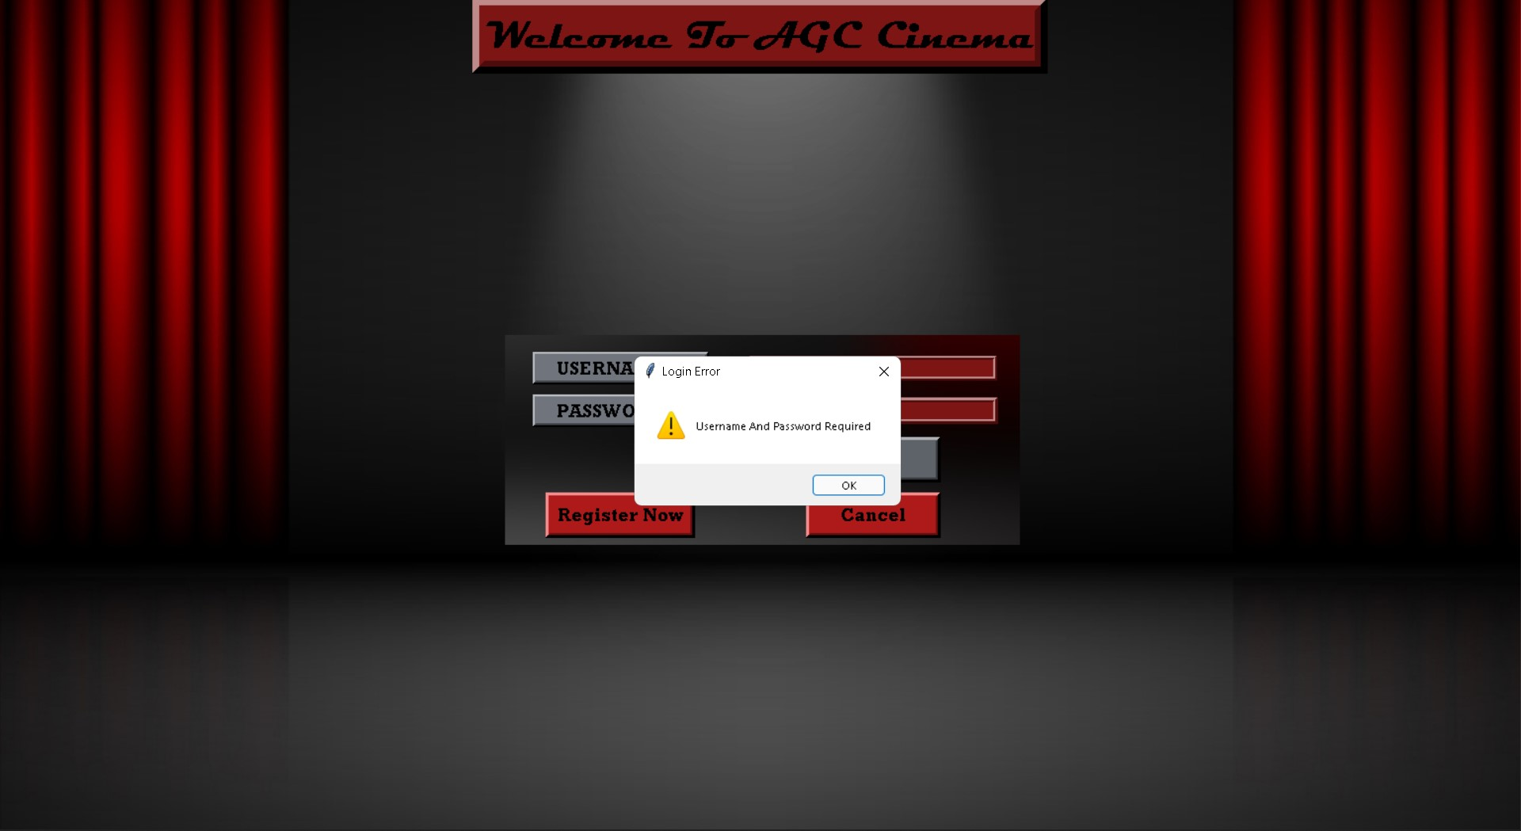

Fig. 2: USER NOT FOUND

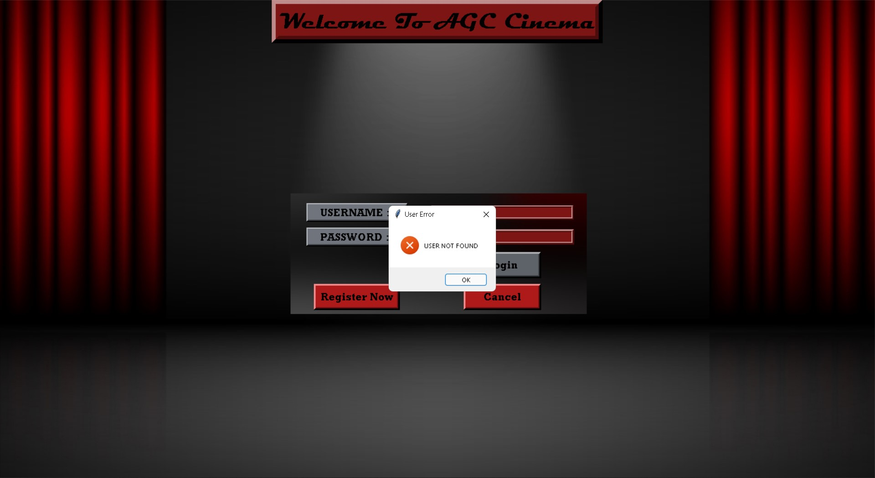

Fig. 3: ASKING FOR REGISTRATION

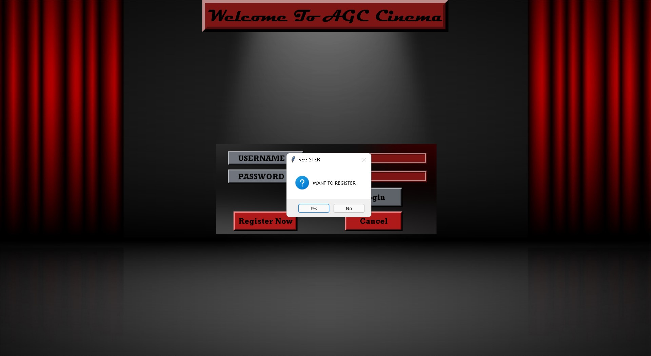

Fig. 4: REGISTRATION PAGE

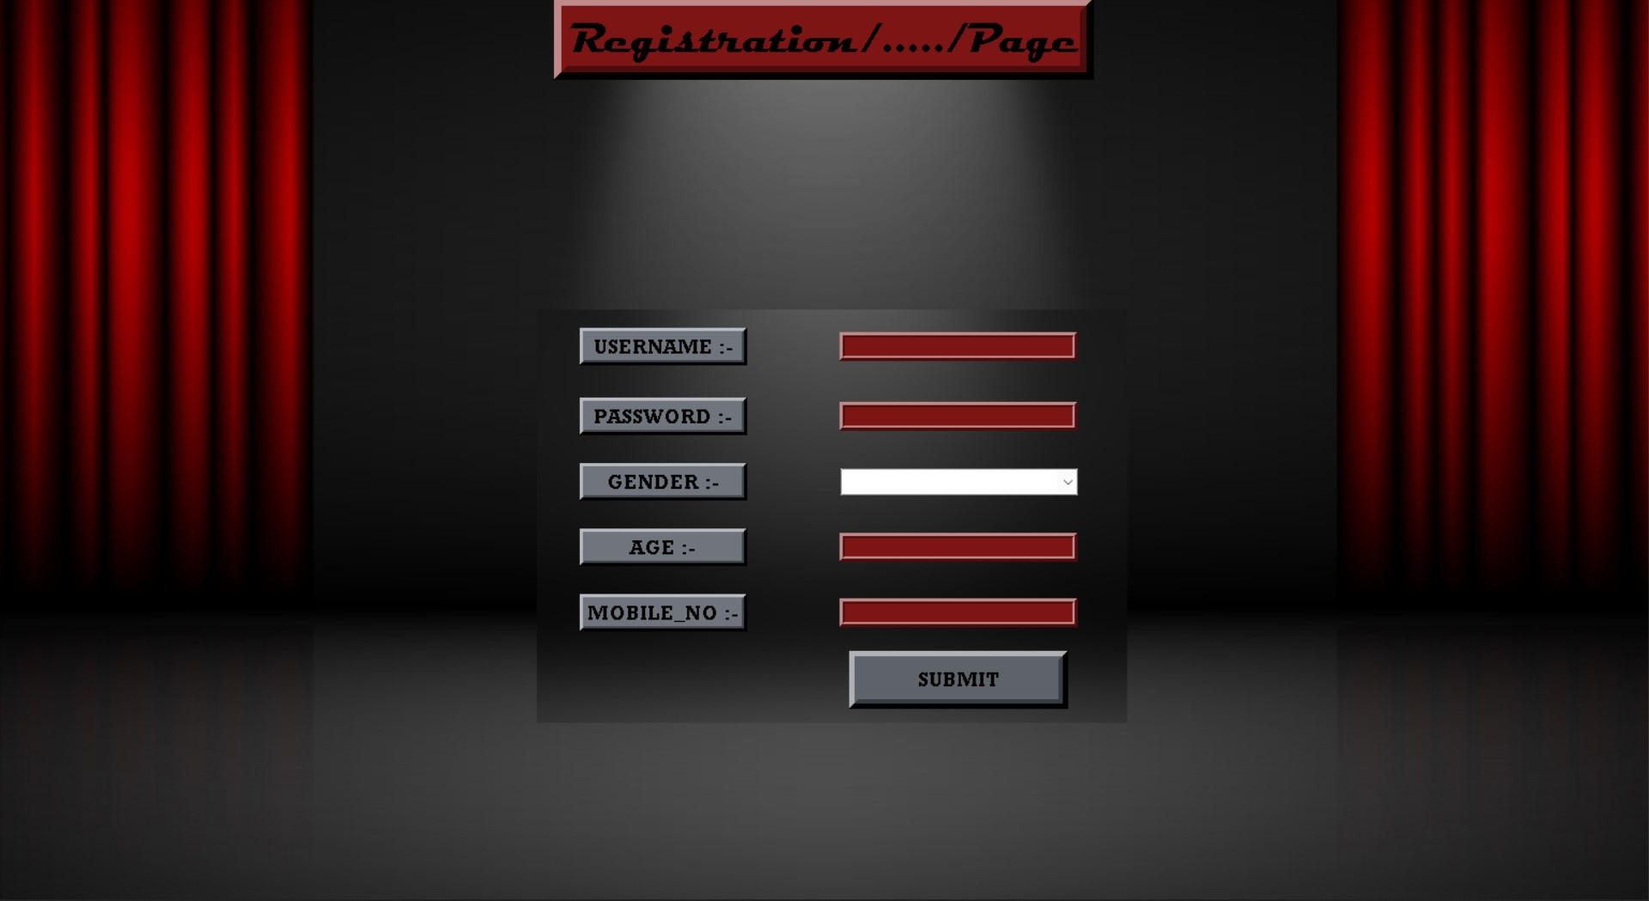

Fig. 5: MANAGER LOGIN

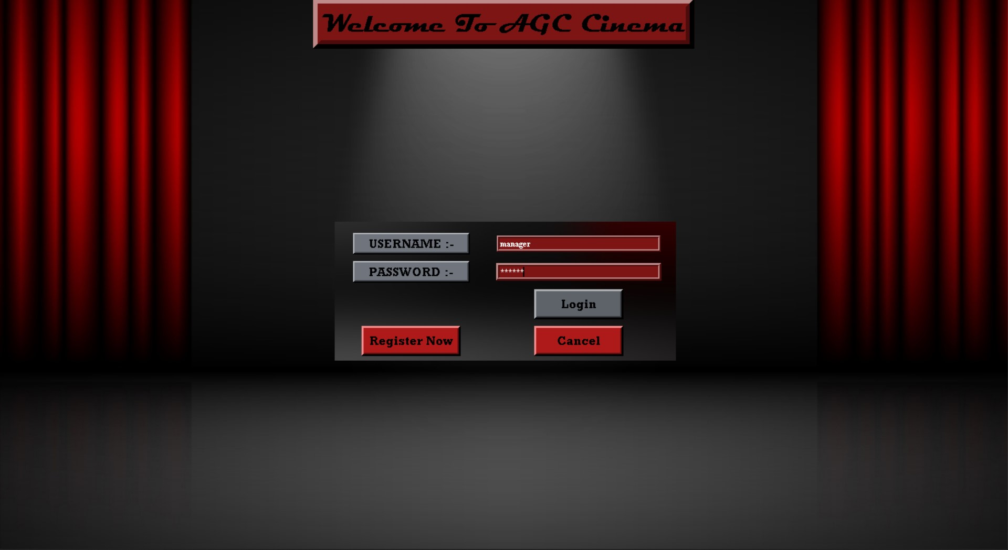

Fig. 6: MANAGER CHOICE PAGE

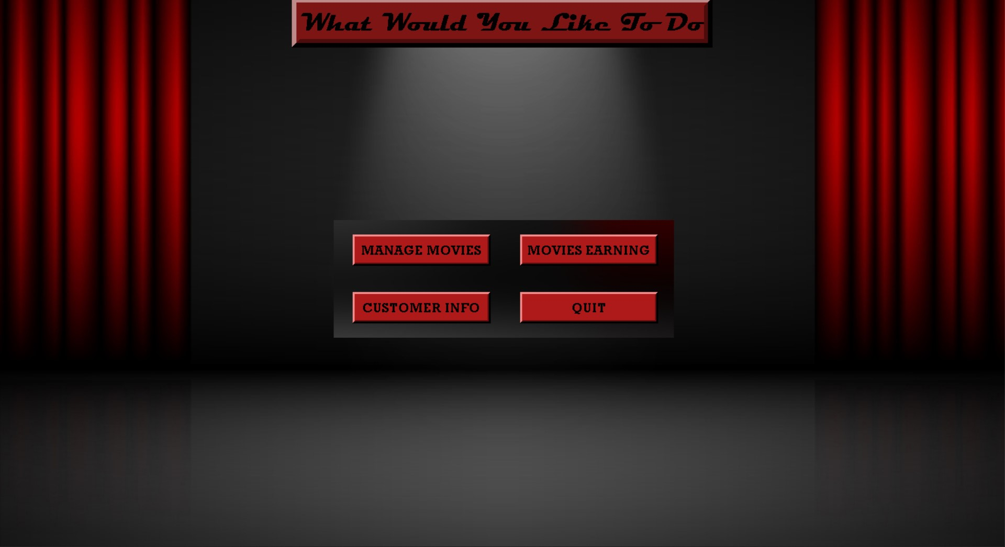

Fig. 7: CUSTOMER INFO PAGE

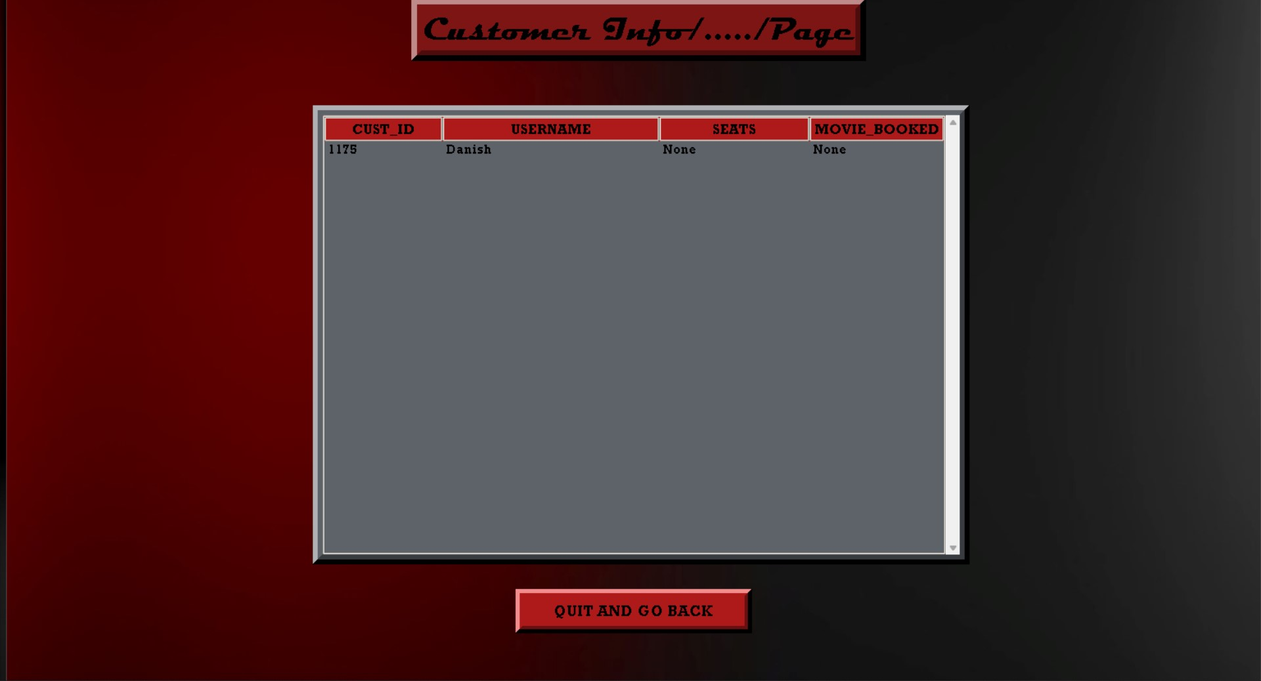

Fig. 8: MOVIE EARNIING PAGE

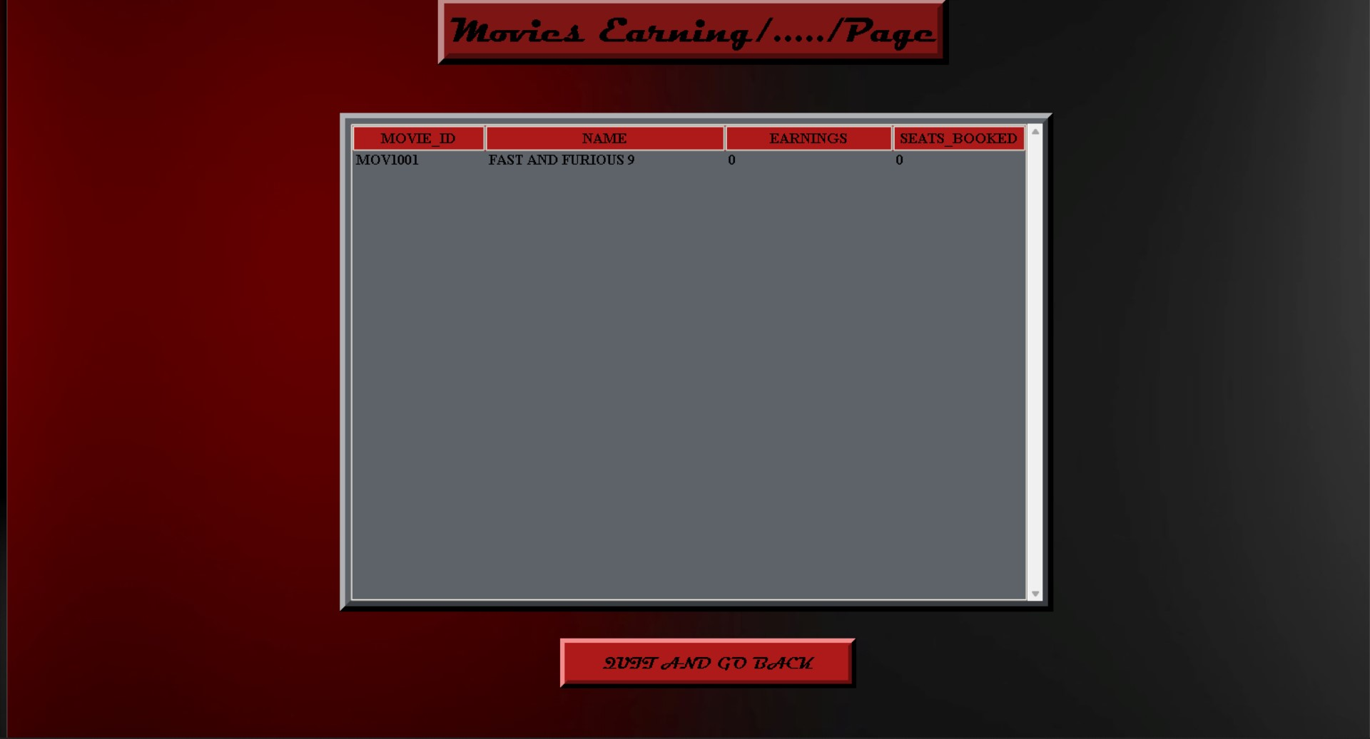

Fig. 9: MOVIE MANAGING PAGE

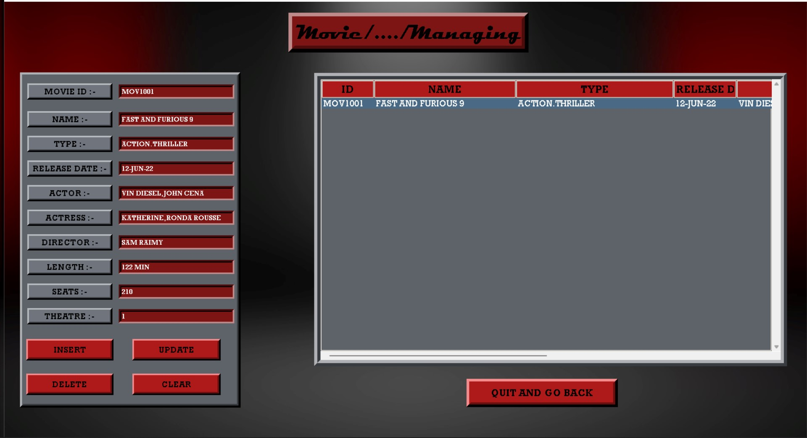

Fig. 10: MOVIE ADDING

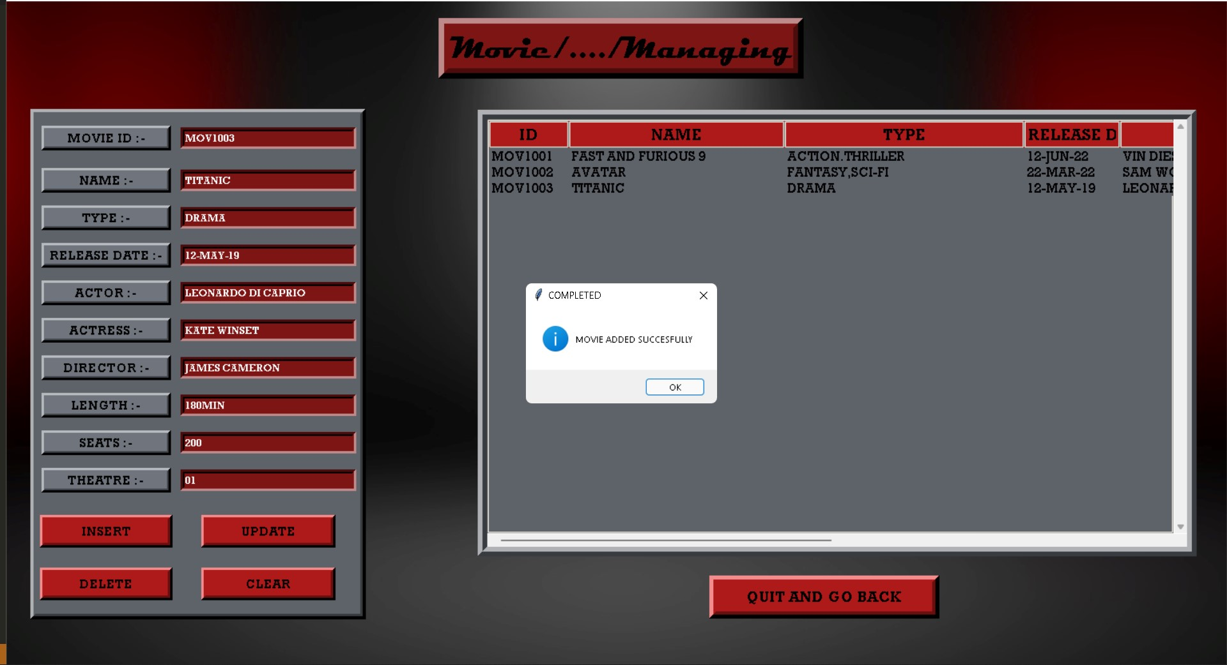

Fig. 11: MOVIE UPDATE

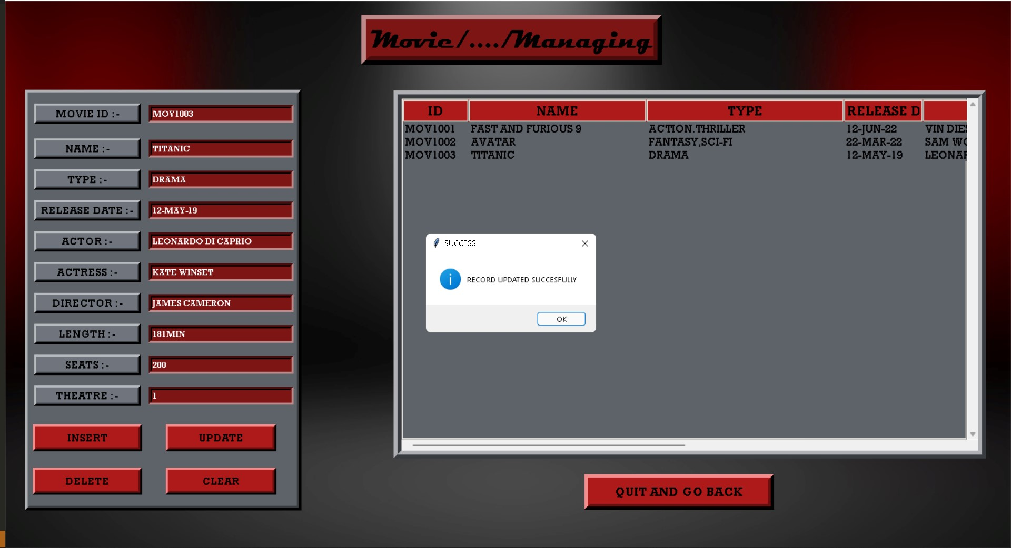

Fig. 12: MOVIE DELETED

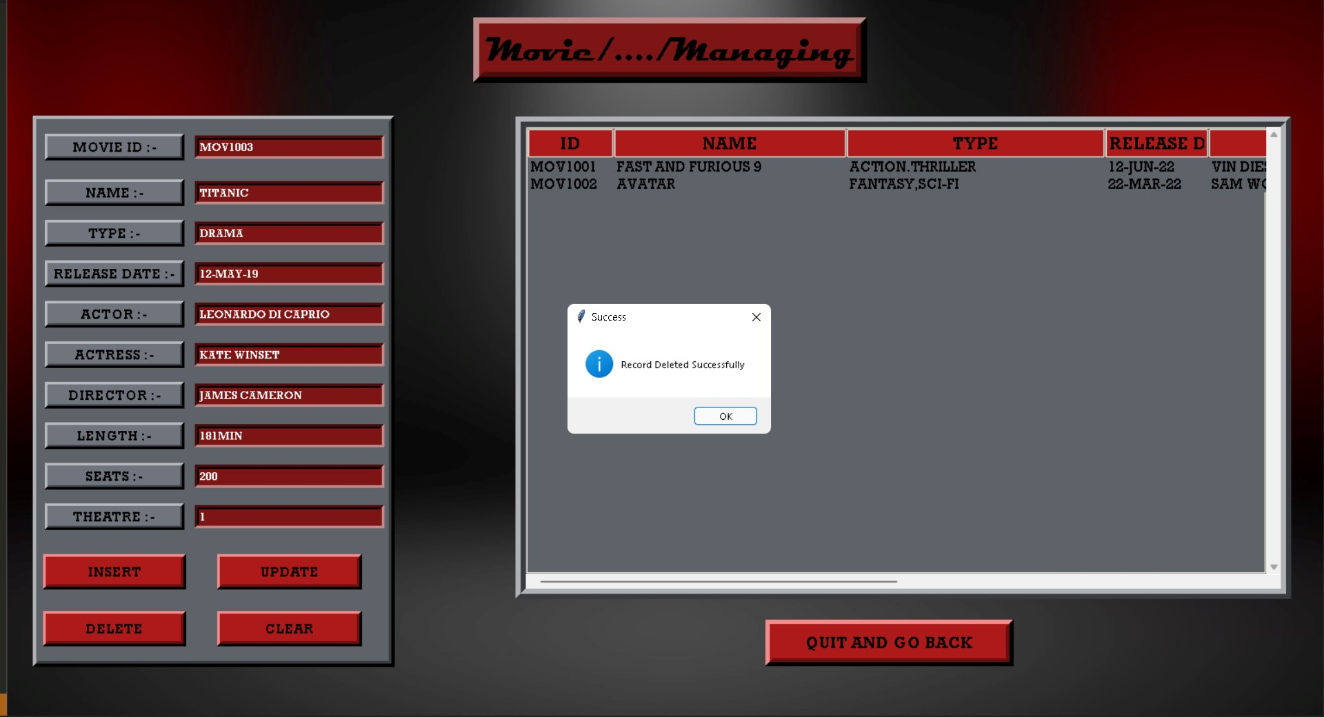

Fig. 13: MOVIE BOOKING PAGE

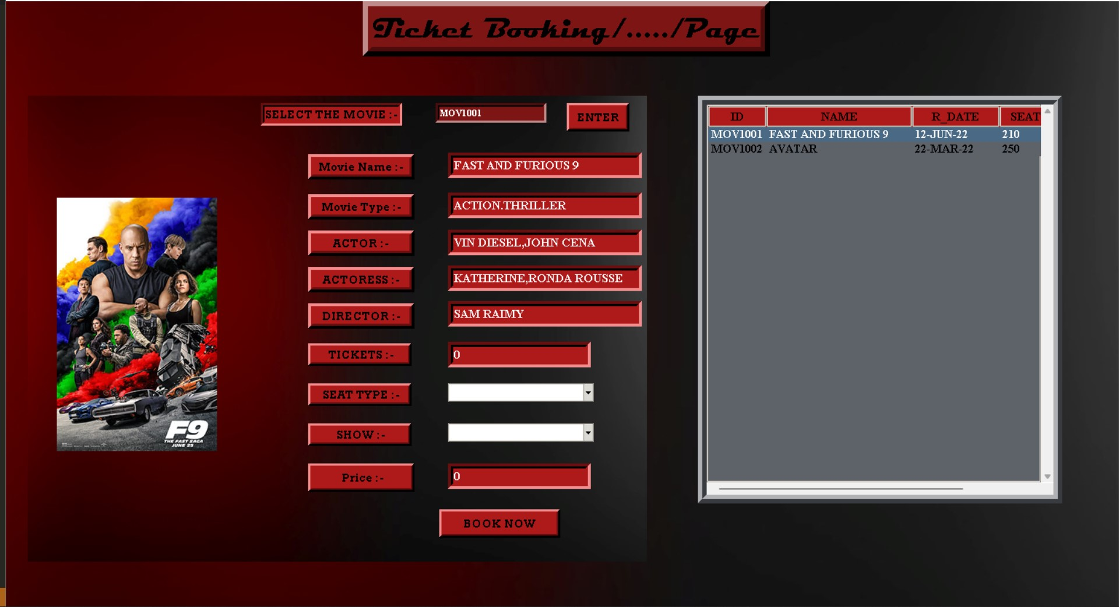

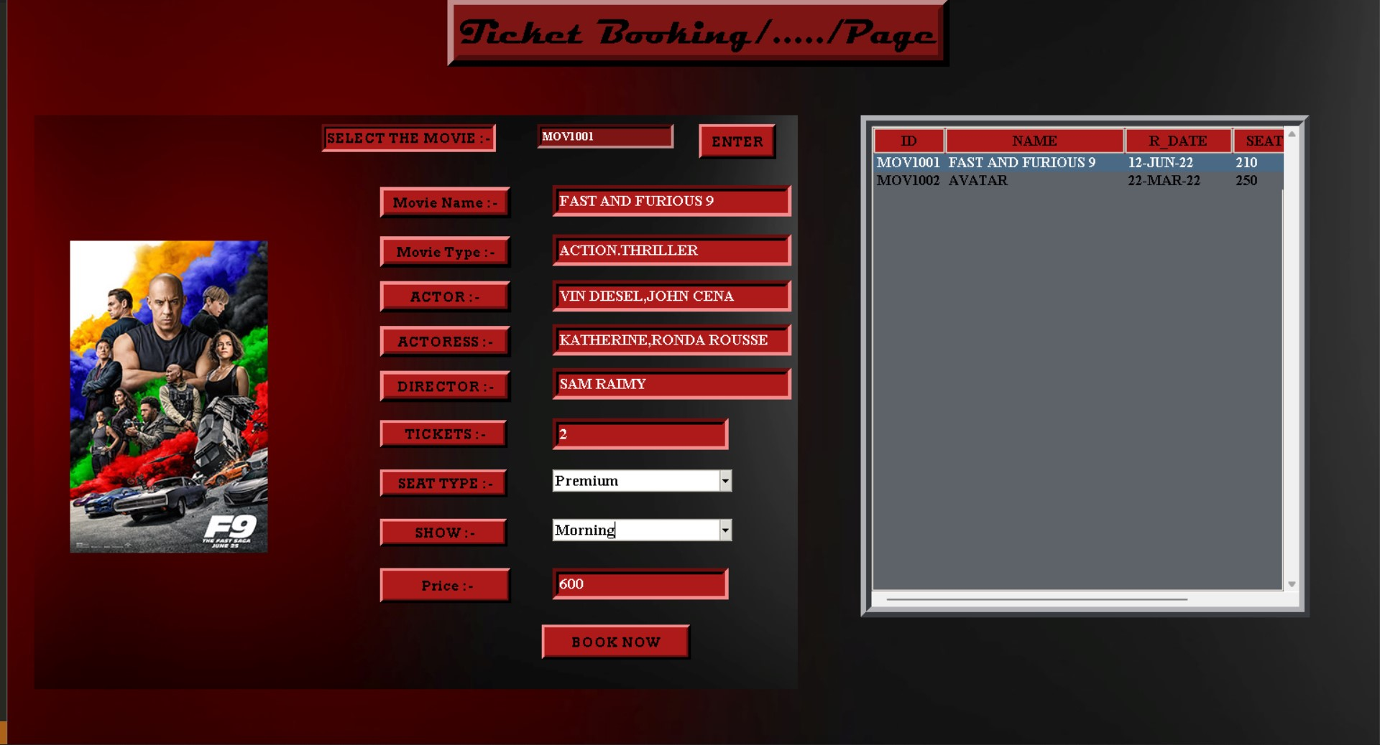

Fig. 13: MOVIE BOOKED PAGE

REFERENCES

https://www.researchgate.net/publication/349265225_EXAMINATION_MANAGEMENT_SYS TEM

https://papers.ssrn.com/sol3/papers.cfm?abstract_id=3611554/A-Study-On-Web-Based-Online-Examination-System

https://coderslegacy.com/python/getting-started-pyqt/

https://zetcode.com/gui/pyqt5/firstprograms/

https://ieeexplore.ieee.org/document/6011131

https://stackoverflow.com/

